**Serverless Web Application on AWS**

**Project Description:**

In this project, you will build a serverless web application using AWS Lambda, DynamoDB, and S3. The application will allow users to create, read, update, and delete (CRUD) items from a DynamoDB table.

**Project Architecture:**

[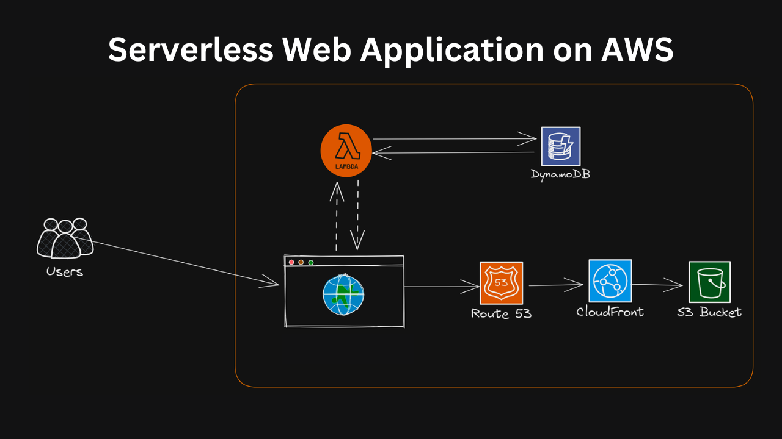](https://user-images.githubusercontent.com/66474973/228492073-5cd3d975-3439-4ce4-b109-fb33997df3c3.png)

**Steps to Build the Project:**

* Create a DynamoDB table to store the items.
* Build a Lambda function to handle the CRUD operations on the DynamoDB table.
* Use S3 to store and host the web application's static files (HTML, CSS, and JavaScript).
* Create a CloudFront distribution to serve the S3-hosted static files with low latency.

**Expected Outcome:**

* Upon completing the project, you will have a working serverless web application hosted on AWS.  
  You will have hands-on experience building a serverless application using AWS Lambda, DynamoDB, S3, CloudFront.  
  Additionally, you will have experience working with AWS services and integrating them to build a complete solution.
* This project will help you improve your skills in cloud computing, serverless architecture, and AWS services.